Operating Systems and Network Project

Ben Redmond – 20041211

Section 1

1. Install VMware/Virtualbox on my Machine.  
     
   I went on the Oracle VM VirtualBox to download the VirtualBox program.

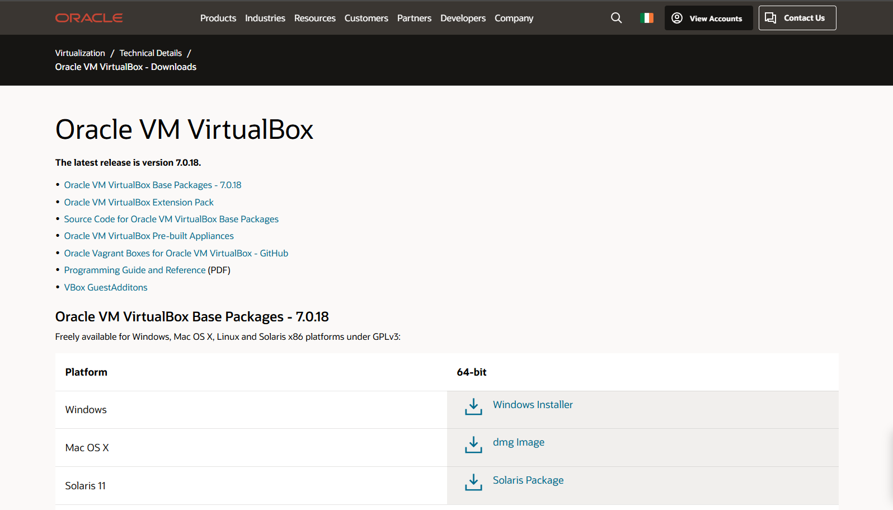  
  
After the installation, the program opened and ran.  
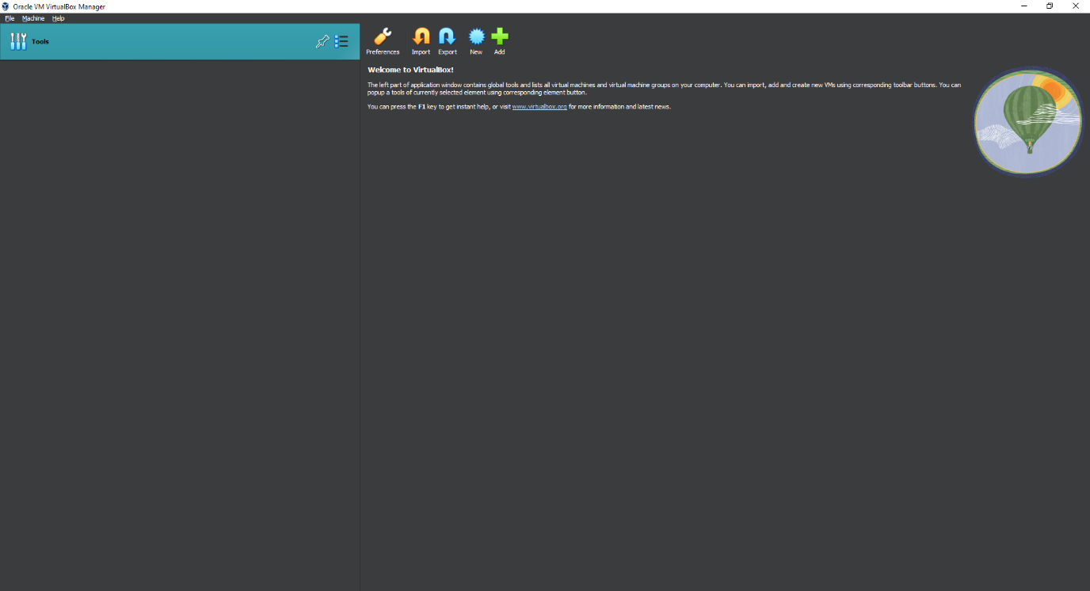  
B. Download and install latest VMDK image of Ubuntu distribution  
  
After downloading a copy of Ubuntu ISO, which is a Linux distribution  
  
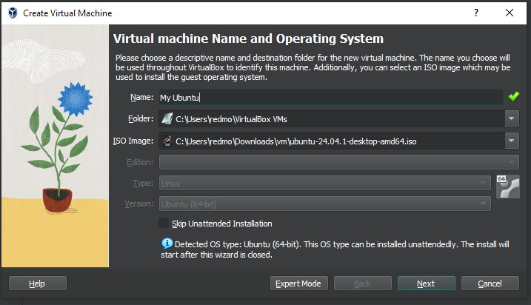

I set a username and password for the Linux VM

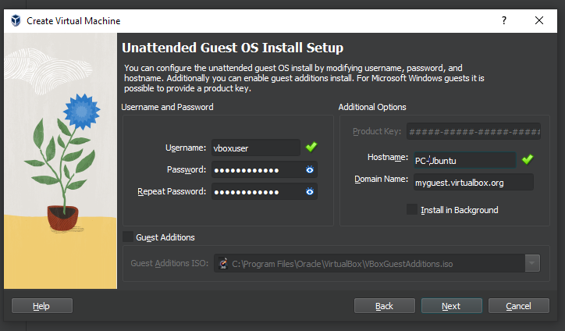

I gave it some RAM and 4 CPU’s

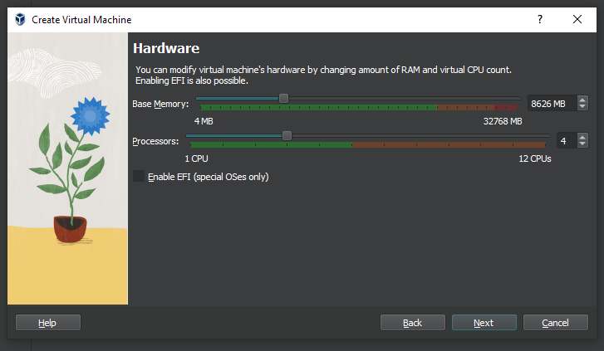

Set up the hard disk to 25.00GBs

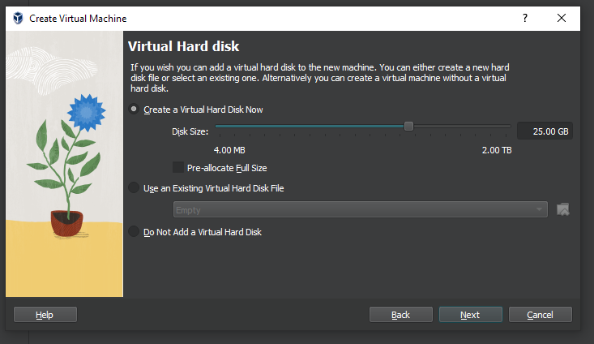

After everything is all set up, the Ubuntu VM is ready for uses

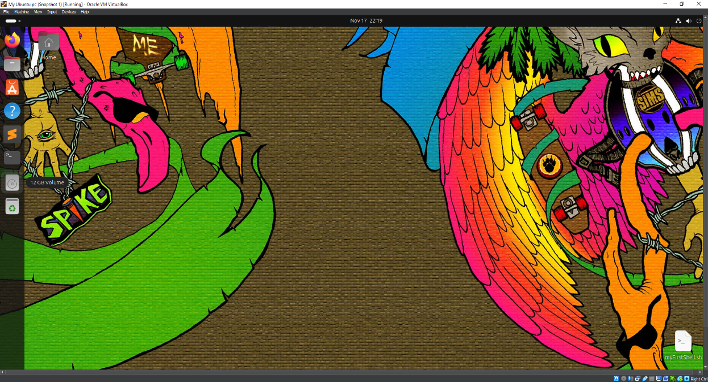

C. There are two types of hypervisors, hypervisor type 1 and hypervisors type 2.

Type 1: A.K.A. Bare metal hypervisor runs on the hosts' hardware without a host operating system. A Type 1 manages the physical hardware and provides an interface for multiple VMs can be run. A type 1 hypervisor provides better performance and efficiency. A hypervisor type 1 is usually used in Enterprise data centres or other Enterprise Environments.

Type 2: A.K.A. hosted hypervisor it runs on an operating system and is a software or application that works by accessing the host OS's resources. Usually hosted hypervisor is mostly used in desktop environments or environments where ease of use is more critical than performance. Type 2 hypervisors are mainly used for software development, testing and learning.

Section 2

A.

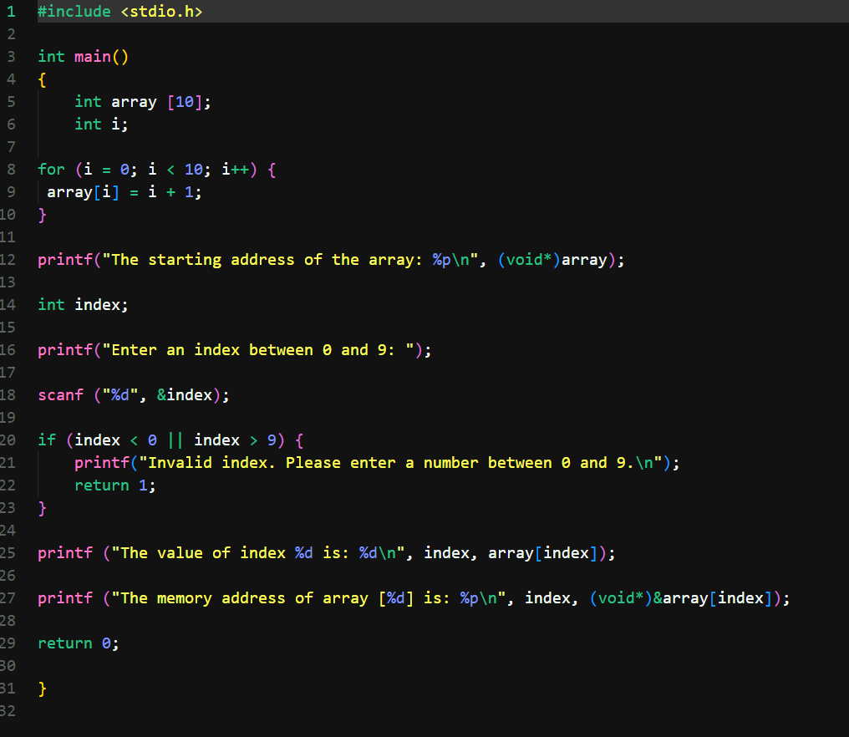

Here is what this code is doing step by step

First you need to declare an array of 10 and an Integer equalling i

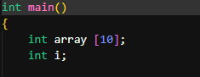

Create a for loop and set i to 0, when i is less than 10 Increment I by

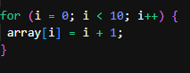

Then print of the starting address of the array and declare a integer called index and prompt the user to enter a number between 1 to 10.

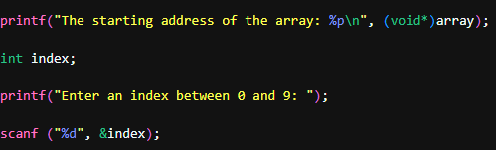

If a user tries to enter a number smaller than 0 or bigger than 9 it will print off a warning to the user to enter a number that we have specified.

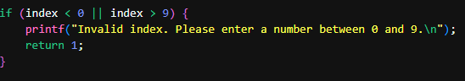

printing off the memory content (value) at the array address. And print off the memory address using the user specified index.

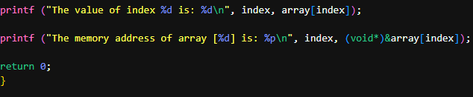

Hopefully the program will run like the following screen shots

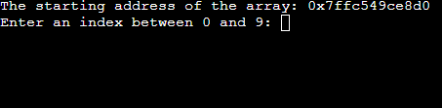

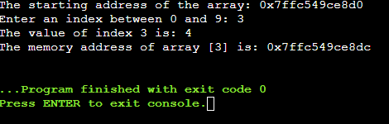

B.

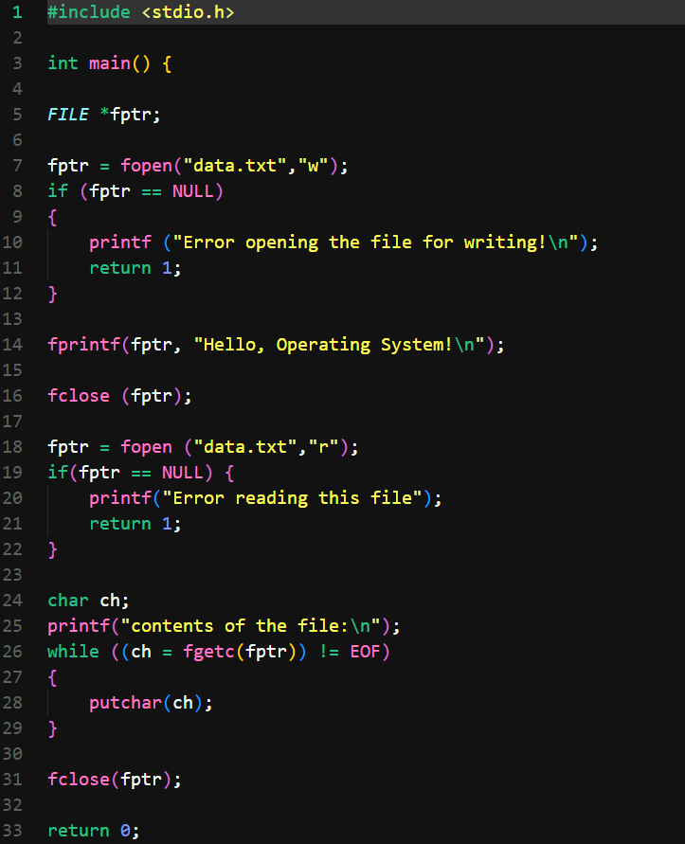

First declare the file pointer, which is C stores the current position of a read or write within a file. Then create a file titled data.txt and attach an if statement that if file is null it will print off an error message.

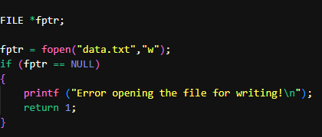

Write a string into the file that says “Hello, Operating System!” then close the file. Open the file again in read mode.

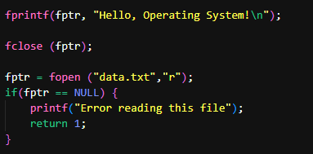

The following code reads the content of the file and then displays it to the console

Than once again file the file.

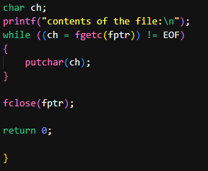

Hopefully when you run the program, this is what you will see.

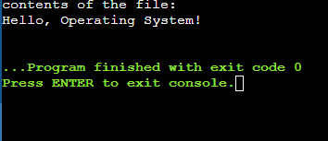

C.